Mating Nuc
Design Process

City University
TCI 550

Stanford’s Design Thinking Framework: | Langley’s Infographic for ADST:
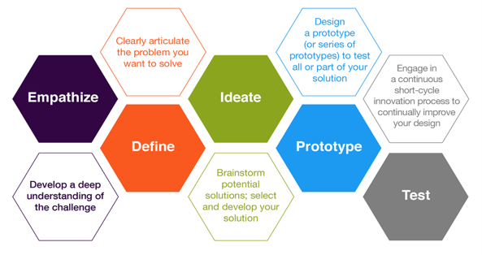 | 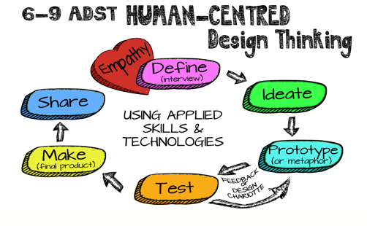

Day 1: Bryn Jones came and presented about honey bees and factors impacting their worldwide decline. The purpose of his presentation was to give us background knowledge in order to build empathy, aiding us in defining our design process for this project.

Empathize and Define:

Globally, there are more honey bees than any other types of pollinating insects; therefore, bees are the most important pollinator of local food crops. However, in recent years, many factors, including habitat loss, disease and pesticide use have contributed to a dramatic decline in honey bee populations.

Local farmer Bryn Jones helps people in the community host beehives on their property. In order to produce enough colonies to support the demand, he needs queen bees. Queens can be mated in a device called a mating nuc. A capped Queen cell is put into a mating nuc together with a sufficient number of attendant worker bees. The Queen then emerges and mates with up to twenty drones. When the Queen returns to the mating nuc, the hope is that mating has been successful. Mating is considered successful if the Queen creates a nice pattern of laid eggs on the frames. Successfully mated Queens can then be transferred to larger hives, creating new colonies.

More Mating Nucs = more New Queens = potential for New Colonies to be established!

Bryn’s presentation provided us background about essential design features, specifically bee space, which can’t be altered at all during any phase of production. Bee space is the crawl space that bees need to pass easily between two structures. 3/8th’s of an inch is the ideal space. Therefore, the space between two surfaces in the mating nuc needs to be the right size. If it is the perfect distance, then the bees will respect the space and leave it free as their passageway. If it the space is not precise, the bees will feel the need to fill it, which can become problematic.

Our goal: To help Bryn improve his current mating nuc. Using two of his prototypes and a store-bought mating nuc, we were are tasked with reproducing the nuc, while also providing some improvements to his current prototype.

Ideate:

Through discussions with Bryn and each other, we concluded that the following three changes would improve upon his current mating nuc design.

#1 – Adjusting the height on the ventilation hole slightly. It will need to be ¼ inch higher in the front as well at ¼ inch higher on the divider. This will increase airflow for the bees.

#2 – Curved finger grooves on the inserts centered on both sides. This will allow for ease in placement and removal of the frame inserts.

#3 – Altering the ‘bee entrance” in two ways:
- First, the door (entrance hole) needs to be lowered so that it is even with the porch.

- Second, we will create a sliding door to control the entry and exit of the bees. The holes will allow for:
- NO BEES to enter or exit the nuc
- A 3/8-inch hole, which will allow for bees to freely enter and exit the nuc
- ¾ inch hole, bees can still enter and exit the nuc, but wasps cannot.

* In the creation of the door, we would need to ensure the that the door DID NOT extend beyond the length of the front of the nuc.

As a group, we determined that it was necessary to prototype the door. See Prototype section for more details on this process.

The remainder of the nuc, we decided to reverse engineer, this process would help us be mindful of ‘Bee Space” and the necessity to keep these sections identical to the current prototype.

Reverse Engineering Specs:

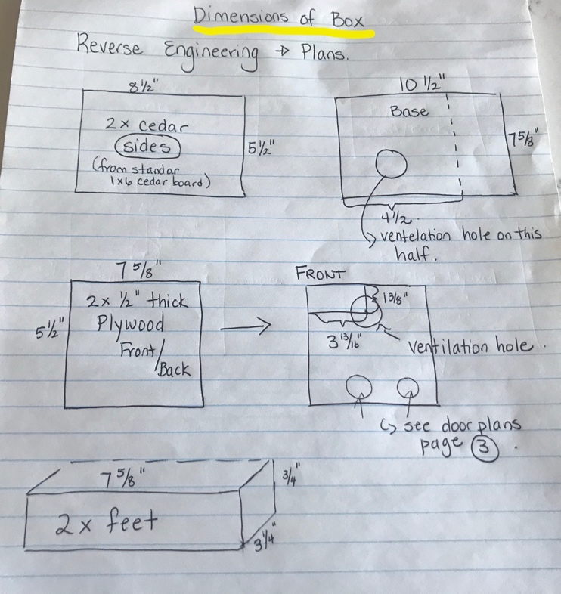 | 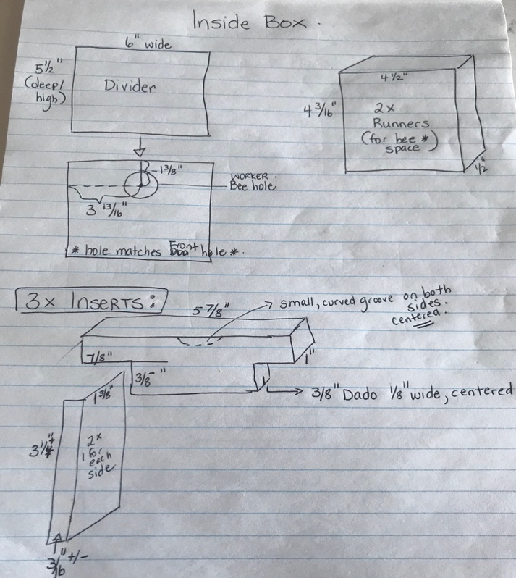

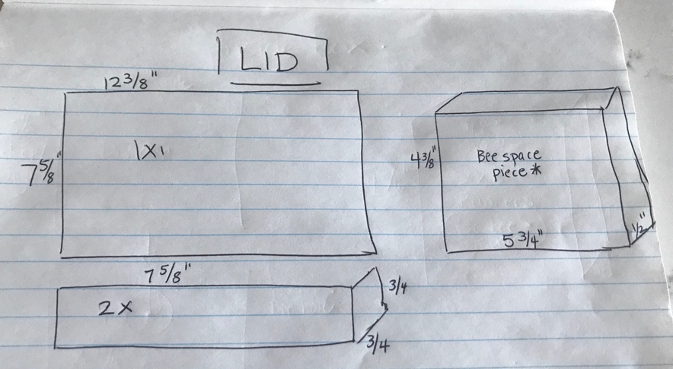 | 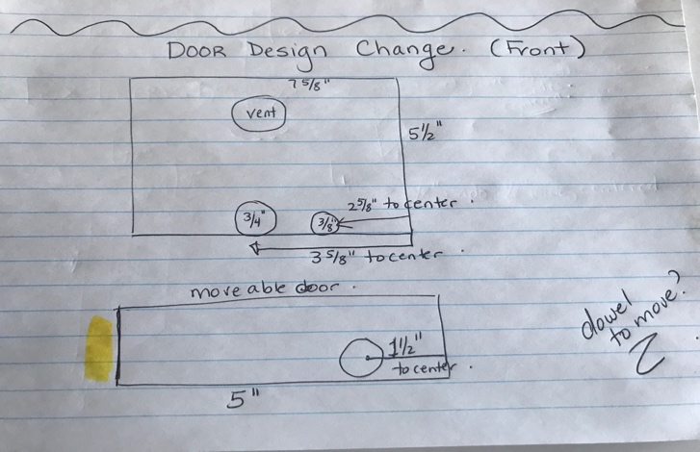

Prototype:
After meeting with Bryn one of the major design changes was going to be to create a sliding door to control the entry and exit of the bees. We knew that we had to prototype the door, figuring out the logistics of how it would work.

In designing the door, we needed to be aware of the following four key design requirements:
- Bryn wanted the bees to be able to walk in and out of the nuc; therefore, the entry had to be on the porch.
- We needed a ¾ inch hole to allow the queen and the worker bees to freely leave the nuc when it was time for mating to take place.
- We needed a 3/8 inch hole for when bees needed to leave, but there was a need to prevent wasps from entering.
- We need the door to be able to fully close, when it was necessary for the queen and the worker bees to stay in the nuc.

Leading into our prototype, we initially thought that we would make the door out of a plastic type material, perhaps chloroplast.
We also determined that it would most likely be best to drill the two entry holes directly into the front of the nuc, then have a ¾ inch hole in the sliding door.
At this point we found ourselves cycling through the Define/ Ideate process that we were specifically for the design of the door.
We first made a prototype out of paper, then we determined that we needed to play with it without worry of inadvertently ripping the paper.
We then created our working prototype out of plywood. We tried a few variations with the placement of the holes, staying aware of our above design requirements.

Here are images of our door prototype:
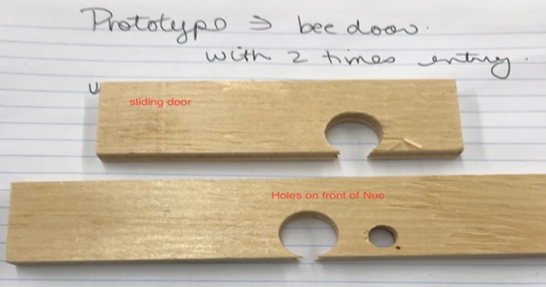 | 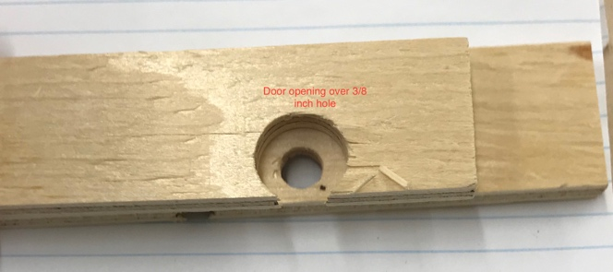
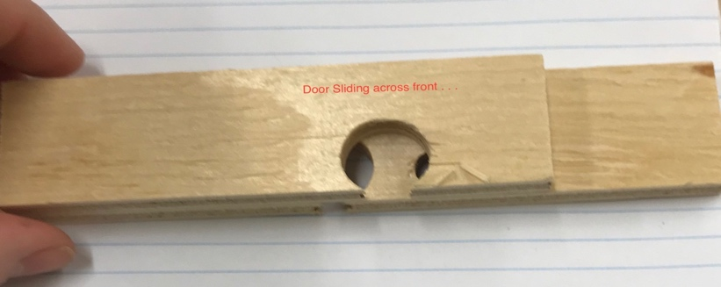

Day 2 – After Presentation of initial prototype for the door and consultation with Bryn.

A few adjustments to the initial prototype for the door included:

- The door will be made out of wood instead of plastic.
- It was be a tight fit - through exact dado’s in the porch and a top supporting piece.
- The new top piece will have the same dimensions as the feet for the Nuc.

Prototype / Test

We began the day by making a prototype nuc that included all of our design changes. We also did an assessment of the materials available and adjusted some of the specs accordingly.

As a result, the plans were alerted slightly:
- The front and back needed to be shorter in length
- Some needed to be taken off the width of the base
- The Worker Bee hole on the divider needed to be moved to center.
- The Dividers will still be cut at 6” x 5 ½ “; however, each one will need to have some taken off the width, depending on the width of the cedar sides, which vary in thickness.
- Failure is an option – need to be aware of the order in which we do things!! See Below: We need to drill holes before we attempt assembly!

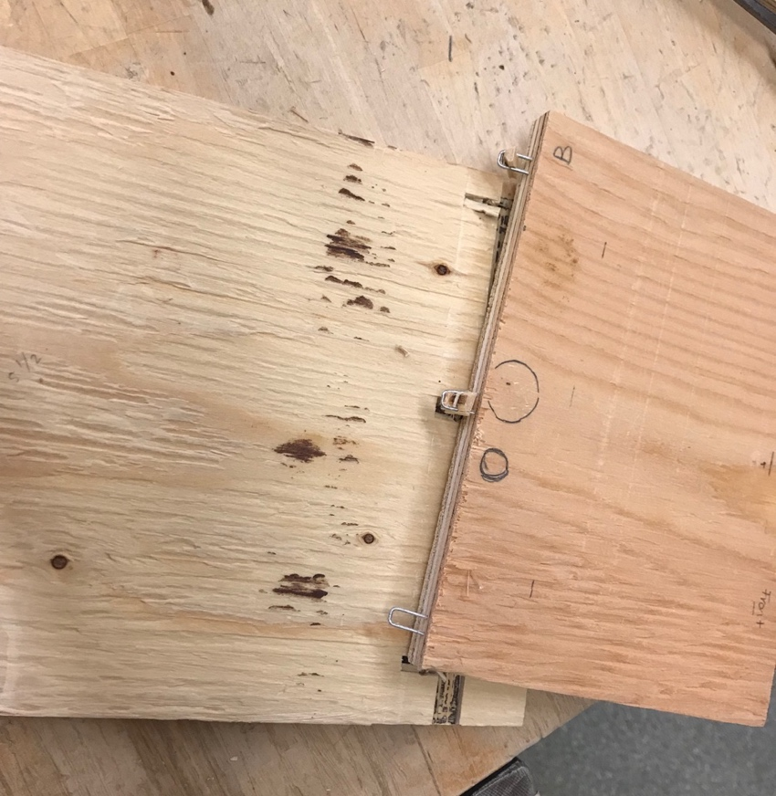

New Engineering Specs (changes are in red):

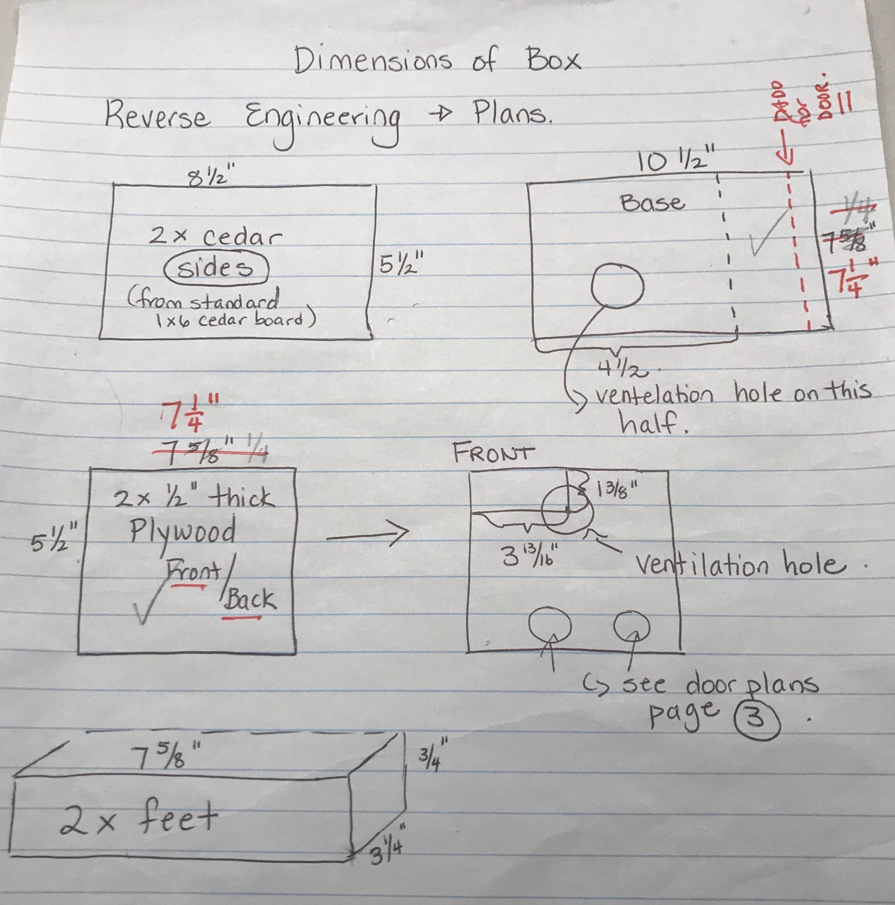

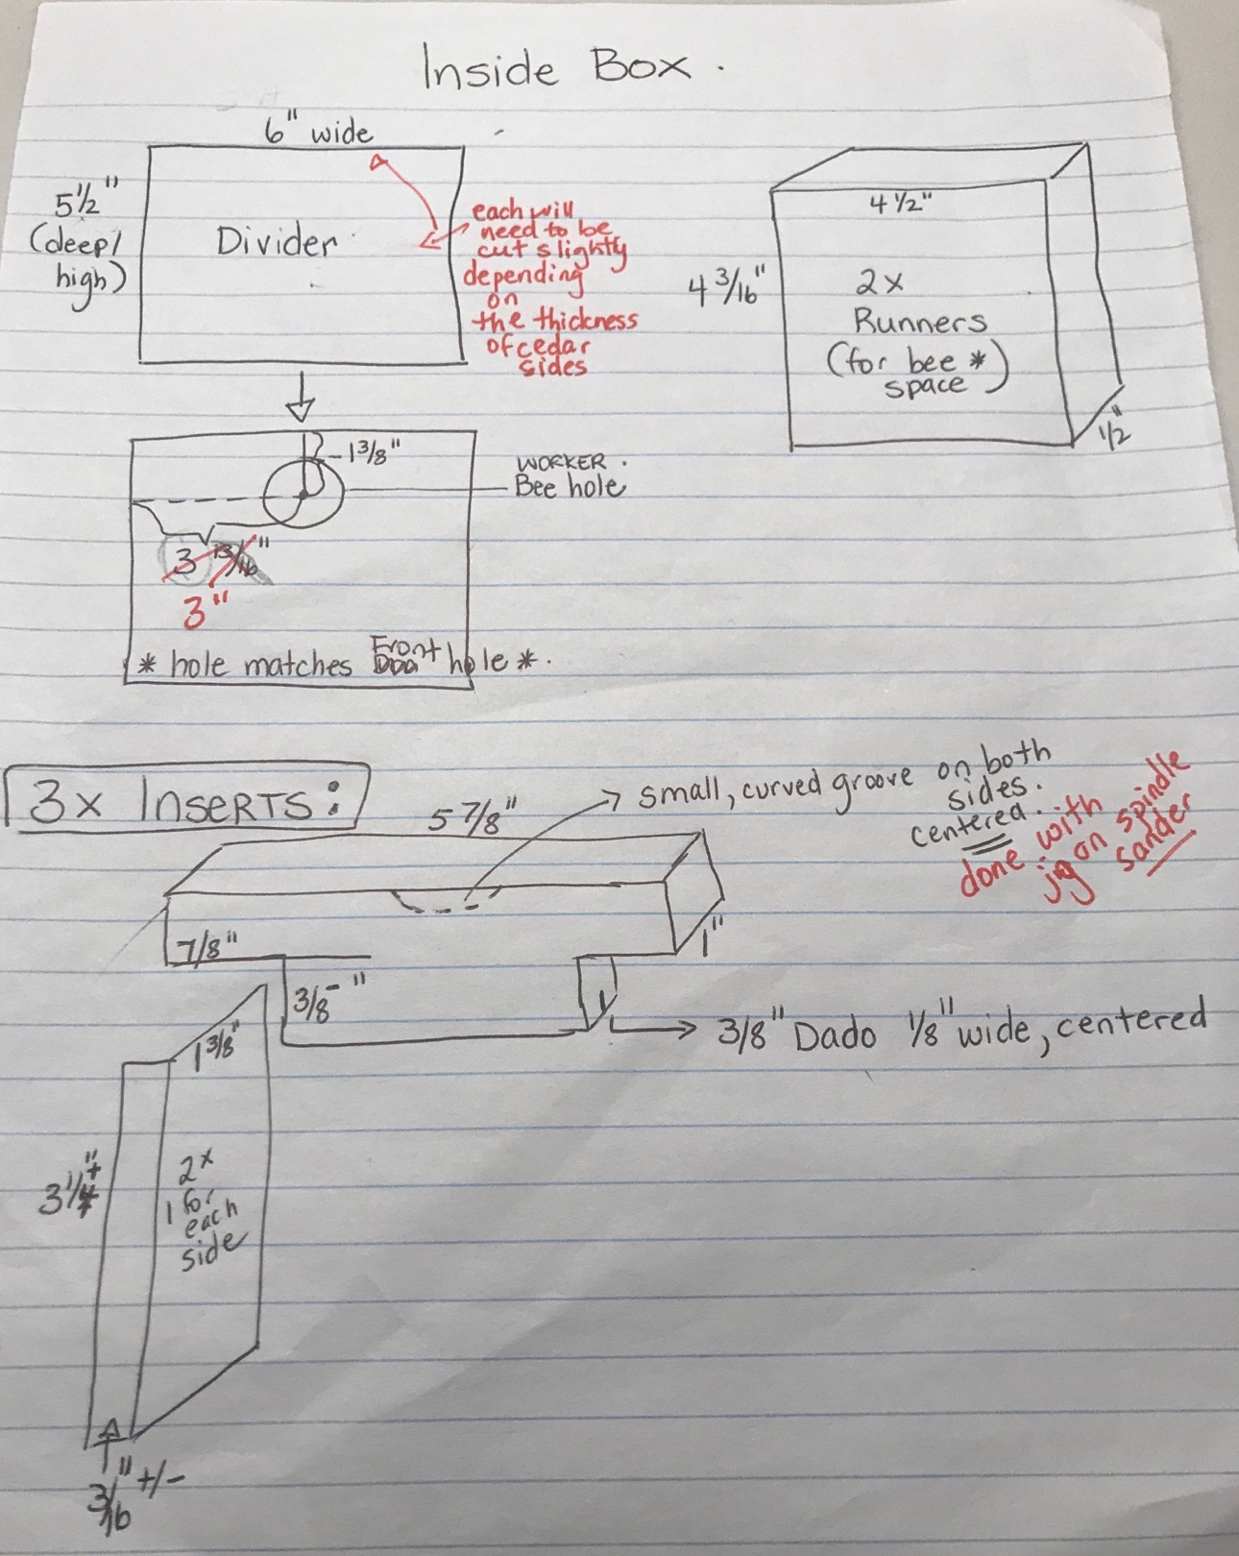
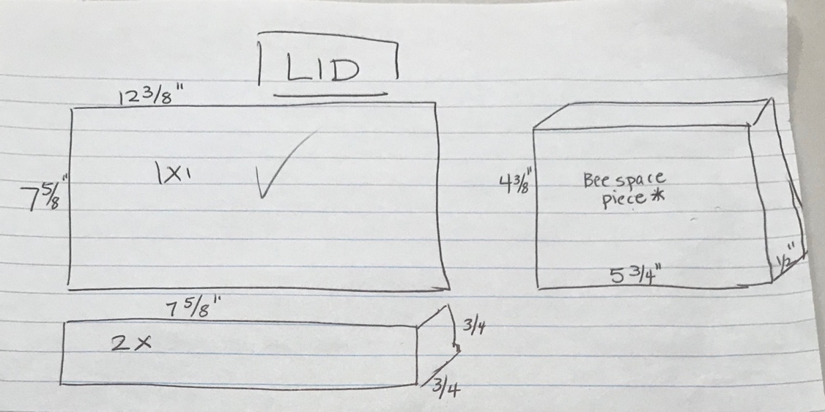

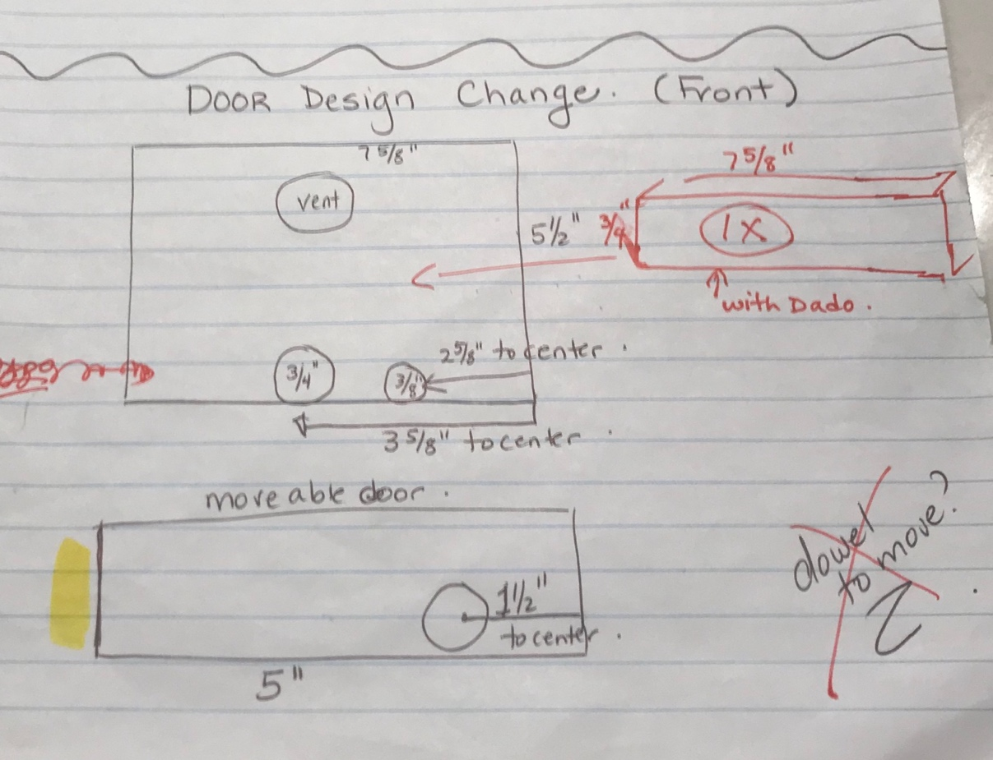

Test / Make:

Throughout the rest of the day, we divided up the labour to make the parts for the mating nuc. This required a significant amount of time, as we cut the pieces for 15 mating nucs. As we were split into different groups and undertook different tasks, our reflections on the Make process are unique. Please see our individual thoughts on the entire process, including the make stage of the design process.

