NAME:___________________
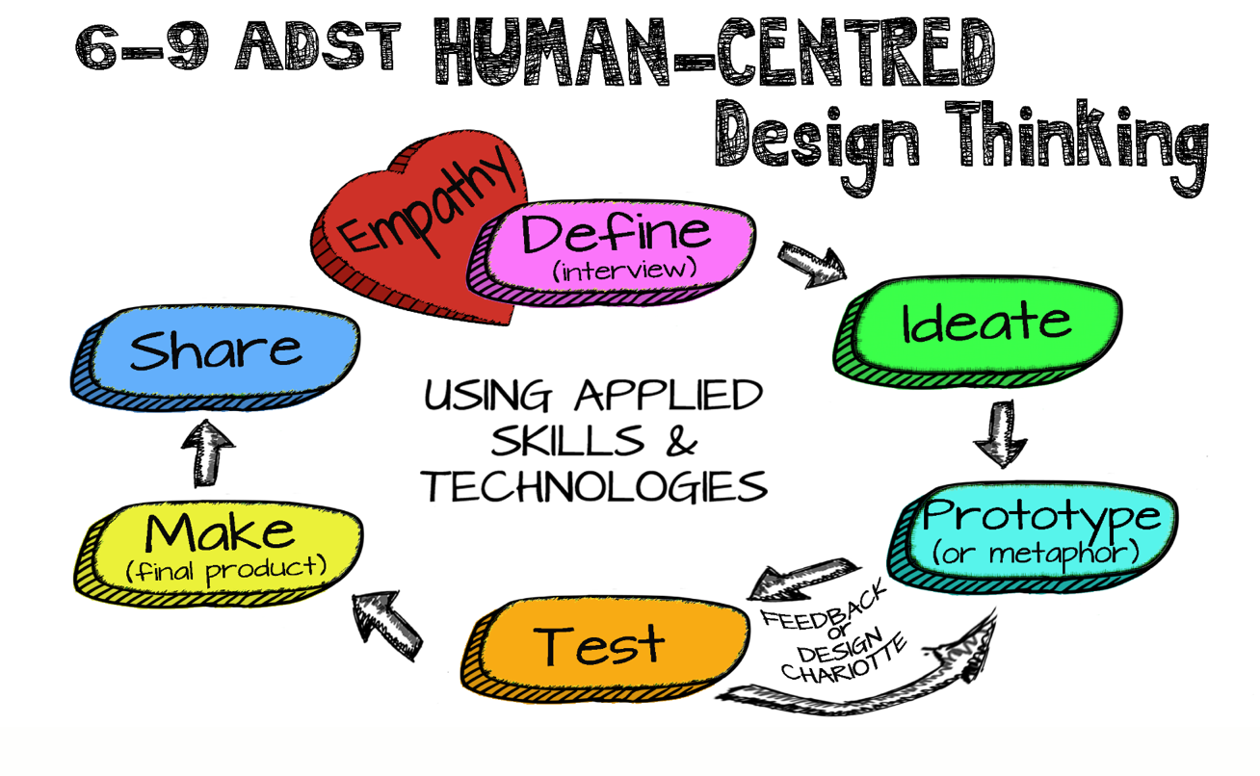

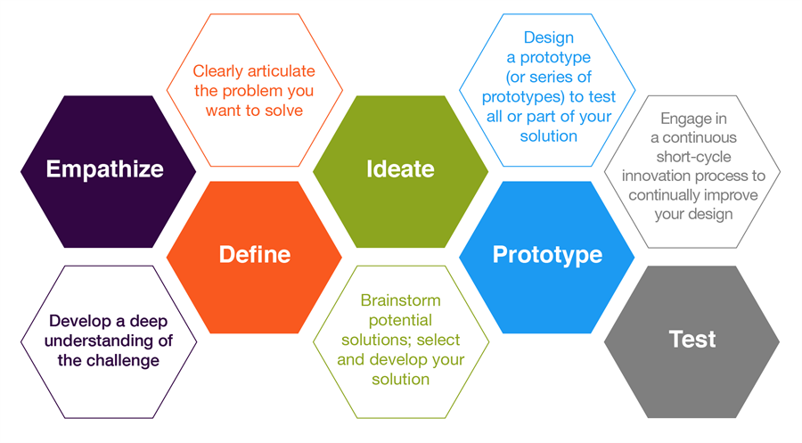

NAME:_____________________ HOMEROOM TEACHER:________________________
DIVISION:__________________

Welcome to the Grade 8 ADST Exhibition of Wonder! A culminating project that showcases your Middle School journey.
Over the past 3 years you have embraced all that middle school has to offer: Making connections with staff and students within our Yorkson community and explored the skills and techniques of “Making” while developing an appreciation of the “art of making”.
Now it is time to showcase what you have learned and show us your passion for learning. Using the Applied Design, Skills and Technologies (ADST) model you will create a project of you’re choosing that demonstrates your learning through an area of passion.
***NOTE: WE ARE LOOKING FOR AN ORIGINAL CONCEPT, NOT A
REMAKE OF SOMETHING YOU HAVE ALREADY DONE***
Follow this guide and document your progress along the way. Make sure you get all the designated “Check-ins” completed by the dates provided in this document.

KEY DATES: Friday March 8th – Exhibition Pitch Day
Thursday April 2nd – Homeroom Teacher approves Idea
Thursday April 18th – Confirm “Sponsor Teacher”
Thursday May 2nd – Confirm Theoretical “Action Plan”
Friday May 17th – Confirm Prototype/Sharing/Building Plan
Monday May 27th – Confirmation of Materials

WORK DATES: Friday May 31st, Tuesday June 4th, Thursday June 6th
EXHIBITION DATE: Monday June 10th
REFLECTIONS DUE: Wednesday June 19th

PHASE 1: COME UP WITH AN IDEA!
EMPATHIZE, DEFINE (INTERVIEW), IDEATE
MY IDEAS: Brainstorm possibilities
MY FAVORITE IDEA AND WHY I WANT TO DO IT:
***NOTE: YOU SHOULD KNOW/STATE THE INTENDED AUDIENCE (SHARE)***
***NOTE: ANY COST ASSOCIATED WITH THIS PROJECT IS THE RESPONSIBILITY OF THE STUDENT/FAMILY***

Homeroom Teacher’s Initials: DUE DATE: APRIL 2nd
Student Signature: _________________________
Parent Signature: ___________________________
PHASE 2: DEVELOP AN “ACTION PLAN”
IDEATE, PROTOTYPE, TEST
Part 1:
EXPANDED IDEATION: Show the entire scope of the project including: genre, new skills, timelines, etc.
Which teacher(s) would best suit my project as a sponsor? _____________
Homeroom Teacher’s Initials: Sponsor Teacher’s Initials:
Student Signature: ______________________ (if needed)
DUE DATE: MAY 2ND
PART 2:
WHAT NEW SKILL/PROCESS AM I GOING TO PROTOTYPE?
Consider these questions:
- How long will the prototype take?
- What will I need to prep in order to prototype?
- What will I expect to learn from the prototype?
- What happens if the prototype makes me consider other options?
- Can I test anything before the designated “build days”?
- Who do I need to consult?

Sponsor Teacher’s Initials: DUE DATE: MAY 2ND
PHASE 3: CREATE/CONFIRM A PLAN OF ACTION
PROTOTYPE, TEST, MAKE, SHARE
PART 1:
PROTOTYPING: How am I going to prototype a skill or process?
Questions to consider:
- Does the prototype need to fully functional?
- Do I have enough material(s) to prototype?
- How do I know the prototype will be successful?
STEP BY STEP PROCESS:

Sponsor Teacher’s Initials: DUE DATE: MAY 17TH
PART 2:
TIMELINE: Break down what needs to be accomplished each day. This should include any step-by-step processes.
DAY 1: May 31st
DAY 2: June 5th
DAY 3: June 6th

Sponsor Teacher’s Initials: DUE DATE: MAY 17TH
PART 3:
PRESENTATION (SHARING):
How do I want to present/display/share my project?
***NOTE: The project will have a specific audience in mind; however, I will be displaying it to a larger audience so I must include the “desired” audience in my presentation***
Things to consider:
- How much space will I have?
- Do I need any power sources?
- What kind of platform will best display my efforts?
- What information will be needed in the display to capture the essence of my project?

Sponsor Teacher’s Initials: DUE DATE: MAY 17TH
PHASE 4: MATERIAL LIST AND ESTIMATED COST

Sponsor Teacher’s Initials: DUE DATE: MAY 27TH
Student Signature: ________________________
Parent Signature: __________________________
PHASE 5: REFLECTIONS/CHANGES
PART 1:
BUILD DAY REFLECTIONS
Questions to consider each day:
- What did I enjoy about today?
- Did I encounter any frustrations today?
  - What did I do about it?
- Did I learn any new information about my project that I did not predict?
  - Did I have to go back to the Ideation/Prototype/Test phases at all?
- Did I use my time wisely?
- Am I ready for next day?
  - What do I need to prepare for next day before the designated build time?
DAY 1 REFLECTION
DAY 1 REFLECTION CONT….
DAY 2 REFLECTION:
DAY 3 REFLECTION
Things to consider:
- Do I need more time to complete the project?
  - How will I do this?
FINAL REFLECTION (OVERALL)
This is a chance to document my learning process. Looking back at everything I have done up to the point of completing the building of the project, can I answer these questions: What have I learned? What would I change? Am I proud of what I accomplished?
Things to consider:
- The ADST process itself
- How did my preparation efforts effect my “creating” efforts?
- How did I overcome and persevere?
- Does my project fulfill a need or answer my definition?
  - What changes would I make if I were to build a 2.0 version?
- Can I use the ADST cycle in other aspects of my learning?
- Who do I need to thank for guiding me through this journey?
FINAL REFLECTION CONT…

FINAL REFLECTION CONT… (IF NEEDED)

COMPLETED REFLECTIONS: DUE BY JUNE 19TH
Homeroom Teacher’s Initials:

