Names: ________________________
Pinwheel Challenge

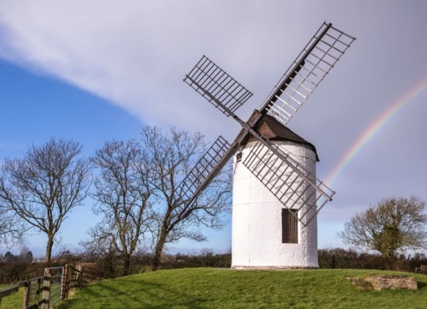
Step 1. Build a basic pinwheel using the template and directions.

Step 2. Determining How Your Pinwheel Works Best

Hold your pinwheel into the fan. Next, turn your pinwheel to a 90-degree angle from the wind. How fast does it spin? Fill your answer in the chart below.

Next, hold the pinwheel in a 180-degree angle (or opposite direction from the 90-degree angle) from the wind. How fast does it spin? Fill your answer in the chart below.

How You’re Holding Your Pinwheel | How Fast It Spins (Fill in Fast, Slow or No Spin)
0◦
Into the fan
90◦
Against the fan
180◦
Against the fan

At which angle did the pinwheel spin the fastest? _________________________________

At which angle would a wind turbine work the best? _______________________________

Step 3. Prototype and Test a new Design

Now that you know the basic design of a pinwheel, you will work with a partner to come up with a better design that allows the pinwheel to spin faster.

3a. In the space below, sketch at least 2 different designs you think will make the pinwheel spin faster:

Step 4: Repeat Step 2 with your new designs and fill in the charts.

Design #2
How You’re Holding Your Pinwheel | How Fast It Spins (Fill in Fast, Slow or No Spin)
0◦
Into the fan
90◦
Against the fan
180◦
Against the fan

Design #3
How You’re Holding Your Pinwheel | How Fast It Spins (Fill in Fast, Slow or No Spin)
0◦
Into the fan
90◦
Against the fan
180◦
Against the fan

Step 5: Summarize Your Results. You should complete a written response that includes – which worked best and why? What kind of adaptations did you make

- S
- S
- S
- S
- S

Step 4. Document the Experiment

Engineers record their designs and procedure so that it can be duplicated! Please write down each step in simple and complete sentences. Be sure to include everything you need to redo this experiment and everything you did to create your prototypes.

