Using Story to Inspire STEM Opportunities In Your Classroom
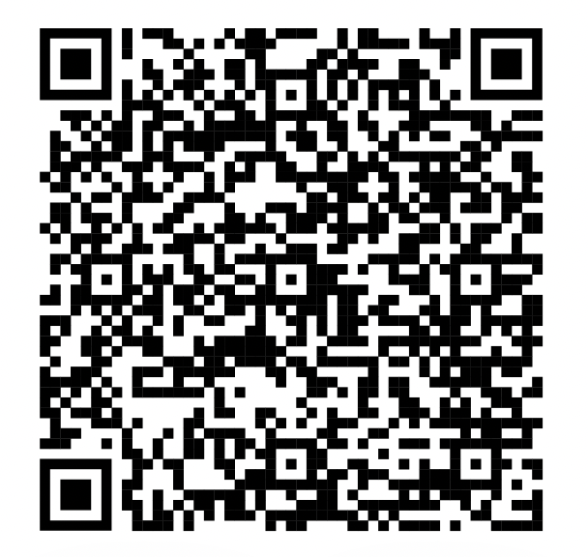
A Workshop Presented by Nadine Keyworth and Jon Fast
A digital copy of this can be found using the QR Code
All resources can be found there.

Contact Us:
Nadine Keyworth Jon Fast
nkeyworth@sd35.bc.ca jfast@sd35.bc.ca
@mrskeyworth @jonfast44

Some of the Featured Activities and Resources in Order

- Some Great STEM Movie Ideas

How we use Movie Clips:
- Create a reflective STEM journal – where students discuss thoughts, ideas, inspiration Use to support learning in the classroom
- Use to show diverse voices and stories in STEM

- https://www.youtube.com/watch?v=d8qOr8oJvVI&list=PL8TjVyuBdsCmq71oQj-_I776KbpmYagkY&index=3

- https://www.cyclesoflearning.com/blog/my-15-favorite-movie-clips-to-use-as-science-curiosity-sparks
- World’s Toughest Race - https://www.youtube.com/watch?v=NhYqctr5sBQ

- Whoosh! by Chris Barton

Great Video about Lonnie Johnson: https://www.youtube.com/watch?v=-1zAO1WkG58
New Story Video Link about Lonnie Johnson:
https://www.cbsnews.com/video/making-a-big-splash-with-the-super-soaker/#x

Paper Rockets Connecting Nasa, his childhood and ultimate design opportunity.– Great video from NASAJPL Edu https://www.youtube.com/watch?v=aTd2f59TSVo

Hydraulics: https://www.youtube.com/watch?v=BFw899OaD0s

Handouts: Perseverance Chart
Hydraulics Planning Sheet
Poppers

- The Boy Who Harnessed the Wind By William Kamkwamba
- There is a full novel and a Netflix video about this as well!
- Themes of Innovation, Energy, Imagination, Perseverance (connect with theme in Whoosh)
- Excellent book to include in a unit on Electricity and Energy Sources
- Pinwheel Design Challenge
Extend Further: Build a Windmill!! / Extend and do a watermill as well

- Someone Builds the Dream – Lisa Wheeler and Loren Long
  - Investigate STEM Careers it takes to build a new building or bridge in your city.
  - Breakdown objects to their natural resources (tie to Science).
  - Doing as JigSaw helps with the collaborative learning process.
  - The Story of a Building is not just who it is being built for, but also who it takes to make it happen and how they collaborate and work together.
  - Build Bridges, Paper Roller Coasters, Elevator Challenge

Handouts: Breaking Down Objects – Blank and PDF filled in
Elevator Challenge

- Creating STEM Opportunities Through Literature
- Great way to create cross-curricular opportunities.
- Use Book Clips – Inspire, respond, reflect similar to movie clips.
- Inspire build opportunities to solve problems.
- Create Literature Circles with Diverse Voices and STEM role models.
- Classroom Read Aloud and School Wide Read Aloud to inspire community.

Some of our Favourite STEM / Design Novels
  - The Science of Unbreakable Things by Tae Keller – Tie to Egg Drop Challenge
  - Spin the Golden Light Bulb – Jackie Yeager
  - Violet and the Pie of Life by Debra Green
  - Clues to the Universe – Christina Li
  - Project Mulberry – Linda Sue Park
  - Solving for M – Jenifer Swendr.
  - Emmy in the Key of Code – Aimee Lucido
  - Wild Robot – Peter Brown
  - SO VERY MANY MORE!!!
Like the classics – City of Ember, Hatchet, Charlie and the Chocolate Factory

HANDOUTS: Build a Boat Challenge
Character Wallet

- If You Come to Earth By Sophie Blackwell & Dear Earth . . . From Your Friend in Room 5
By Erin Dealy Illustrated by Luisa Uribe
https://www.youtube.com/watch?v=ejHlI16VQdo

https://www.youtube.com/watch?v=DCaoStYIQwo

- Uma Charts Her House – Reif Larsen and Ben Gibson
Fantastic to spark a wide variety of Science and Math lessons

